Matthew L. Jordan

2800 South 110th Court, Suite 1

Omaha, NE 68144

Phone: 402 838 6140

Email: simbiko@global-corporate-training-solutions.com

__________________________________________________________________________________

EXPERIENCE – Corporate Trainer and Professor
English as a Second Language Teacher (CELTA)
Private Instructor, School Instructor, and Coordinator
- Developed and taught individual client base of Business English clients
- Taught Business English to several executives at Braskem petrochemical company
- Taught English at Park Idiomas, Achieve Language School, and the Simbiko Institute (my own company)
- Developed curriculum and conducted Train-the-Trainer programs for Achieve Language Schools
- Led and taught Welcome to Brazil language program, a World Cup and Olympics language program, for Achieve Language Schools
- American Cultural Center - taught and developed English language programs for young professionals and executives with the United States Embassy in Dakar, Senegal
ReferenceUSA, a division of InfoUSA (business and consumer marketing)
Account Executive for New York and Canada
- In charge of sales, marketing, and product development for online business and consumer databases in the State of New York and parts of Canada – customers included major public libraries, universities, government agencies, large companies, and small business owners
Duties included:
- Maintained and upsold a portfolio of clients in New York and Canada as well as prospecting for new customers and achieving monthly sales goals
- Conducted extensive market research, performed needs assessments, wrote RFP’s for government contracts, set prices, forecasting, handled technical issues, and set up list and email campaigns
- Created marketing materials and marketing plans for customers
- Participated in tradeshows, webinars, and developed price comparison models for new and existing customers
- Facilitated multi-departmental meetings for government and library departments
- Trained librarians, patrons, and small business groups on ReferenceUSA’s suite of business, consumer, medical, governmental, and international products
- Conducted customer service in French and occasionally Spanish and Portuguese
- Worked on four major projects: Federal Broadband Initiative, New York State Crime Prevention Program, New York statewide multi-government agency contract, and New York statewide library deal
- Student at the University of Nebraska Omaha – GIS Mapping graduate program
Continued on next page

Diversified Property Resource
Vice President of Leasing and Marketing
- In charge of development and execution of leasing plan for real estate portfolio
- Leasing and management of several retail, office, industrial, and farm properties
- Auditing of tenant sales, financial statements, and inventories
- Critiquing and developing new tenant business plans
- Ongoing tenant relations and business development
- Negotiating, writing, and interpretation of legal contracts
- Pricing and coordination of new tenant construction
- Resolution of property management issues
- Strategic partner in the remodeling and remerchandising of shopping centers
- Licensed Nebraska real estate salesperson and certified leasing specialist (CLS)
- In charge of development and execution of marketing plan for real estate portfolio
  - Demographic and psychographic profiling
  - Creative development of ad campaigns and media buying
  - Budgeting and ROI analysis
  - Event development and coordination
  - Sponsorship development
- Ongoing market research and development of marketing plan for individual tenants,

shopping centers, and other properties
  - Development and management of rockbrookvillage.com and its online marketing strategies, such as Search Engine Optimization (SEO) and email registration incentives
  - Certified marketing specialist (CMS)
First Data Resources (banking and credit card processing)
Senior Training Specialist/Consultant
- Trained clients on best practices of FDR mainframe credit card processing system
- Managed training programs, from needs assessment to conversion, for GE Capital and Bank of Montreal – received “Quantum Awards” for teamwork on both conversions
- Designated as departmental liaison for French-speaking clients
- Created training materials in conjunction with product development teams
- Designed and coordinated multi-departmental seminars on specialized marketing products
- Mentored new trainers and client service representatives
St. Mary’s University
Grant Writer / Program Manager for International Grants

- Lead writer for grants with USDA (National Institute of Food and Agriculture)
and Department of Education (International Foreign Language and Education)
- Awarded collaborative federal grant between St. Mary’s, Texas A&M/Borlaug Institute of International Agriculture, and Texas A&M – Kingsville, USDA, Foreign Agriculture Service - $1M over 4 years
- Lead program manager, facilitator, and co-professor of USDA NIFA 2023-2026 HSI Grant – my teaching role focuses international business and trade
- Development of innovative 3-Tier pedagogical model – Level I (COIL – Collaborative Online International Learning), Level II (study abroad to Brazil, Mexico, and Guatemala), and Level III (internationally-related internships)
- Pedagogical research and publishing on effectiveness of international programs that promote the development of student skills – personal, cultural, and professional competencies – as well as the development of knowledge and interest in international agricultural knowledge/interest and global citizenship
- Development of relationships with Hispanic Association of Colleges and Universities, PUC-Parana in Curitiba, Brazil, TIEC (Texas International Education Consortium), Texas Department of Education, SUSTA (Southern United States Trade Association), Texas Pecan Growers Association, and several other international public and private trade organizations and companies
- Lead on Memorandum of Understanding between St. Mary’s University and USAID – MOU includes language related to developing faculty expertise via virtual workshops, grant writing, faculty and student exchanges, faculty technical consulting projects, case study competitions, fellowships, internships, development of curriculum related to international development, and DEIA practices
- Grant opportunity webinars and training with USDA, Department of Education, and USAID
- Organizer of international grant cohort of St. Mary’s professors from Economics, International Global Studies, Modern Languages, Psychology, Engineering, and Business

Center Director

- Director of Center for Global Business Studies
- Creation and development of Center’s Strategic Plan, focus on sending more students and faculty overseas, providing funding and logistical support for this travel, and hosting events and guest speakers that foster global awareness
- Management of marketing and budgets related to Center’s strategic goals
- Creation and management of “working” Board for Center for Global Business Studies
- Annual Global Lecture Series development and coordination
- Procurement of guest speakers with expertise in international business and diplomacy – 6 speakers per year
- Ongoing development of internship pipelines and projects for business school students with private sector companies, non-profit organizations, institutions of higher education, and government agencies
- Participation in relevant trade organizations, such as International Business committee – Hispanic Chamber of Commerce
- Regional trade trips related to international business, trade and logistics, and marketing
- Partnering with appropriate government agencies – San Antonio Economic Development Foundation, US Commercial Services, Foreign Agriculture Services, City of San Antonio, and US Department of Agriculture
- Development of relationships with regional universities that have degree programs in international business, trade, and marketing (Texas A&M, UTSA, UT Rio Grande Valley)
- Ongoing development of International Business Practicum class for IB majors – includes international business simulation, Global Lecture Series, case study competition, socio-cultural activities and lectures, and real-world consulting projects between IB students and companies around the world
- Pedagogical research and publishing on effectiveness of various Center programs that promote the development of student skills – personal, cultural, and professional competencies
Executive-in-Residence
- Development of faculty-led study abroad programs to Brazil, Mexico, Portugal, and other countries
- Placement and coordination of students in study abroad programs all over the world, which involves extensive work with the Center for International Programs
- Development of international business research programs
- Development of internationally-related service learning projects
- Advising International Business students on international business, trade and logistics, and marketing
- Research and publishing related to Best Practices of International Business Practicums at small universities and how they lead to student employability and success post-graduation
- Research and publishing on Best Practices of “virtual” study abroad programs, internships, and projects
- General career advising and assistance with internship and job placement opportunities

Johnson & Wales, National University, Bellevue University, University of Nebraska, St. Mary’s University

International Business and Marketing Professor

- Design and delivery of several new online courses – International Business (graduate and undergraduate levels), Doing Business in Latin America, in Africa, and in Asia Pacific, Seminar on European Union, International Communications and Negotiations, Operations Management, Marketing, Entrepreneurship, Sustainability, Technology Management, and an International Business Practicum (trade and marketing tracks)
- Teaching of international business to undergraduate and graduate students with a focus on entrepreneurship, business planning, and marketing (digital and traditional)
- Online, in person, and hybrid teaching at all universities
- Canvas, Blackboard, and Brightspace certified
- Procurement, development, and delivery of relevant summative projects with local and international companies and organizations, which are fully integrated into the curriculum of all classes mentioned above – In Person and Virtual projects
- Development of partnership between Greehey School of Business and Office of Civic Engagement – Service Learning projects related to business and economic development (in persona and virtual)
- Advising of business school, international relations, and modern language students on all degree programs and requirements
- Assurance of Learning duties required for AACSB accreditation
- Volunteer work with VITA, Catholic Charities, and other Service Learning organizations (in connection with Office of Civic Engagement)

Continued on next page

WorldStrides, CIEE, ISA, Brasil Cultural, Summit Global Education
Program Coordinator, International Business Professor
- Scheduled business visits for US based MBA and EMBA programs
- Developed agendas with multinational companies to meet academic needs of US based programs
- Traveled with university groups to help facilitate better meetings and on the ground activities
- Developed consulting projects between universities and South American, European, African companies
- Managed relationships, schedules, and needs of internal teams, university clients, and companies
- Developed agendas, curriculum, and budgets for undergraduate business students
- Taught classes in economics, cross-cultural differences, and Doing Business in Brazil/Latin America
- Scheduled and facilitated guest speakers
- Coached students on how to obtain internships and more permanent work
- Organized and lead programs in Rio de Janeiro, Sao Paulo, Salvador, and Manaus

EDUCATION
Thunderbird, The American Graduate School of International Management
Master of International Management (MBA); Honors in French and International Studies
Academic/Career Focus: International Marketing; Africa and Europe; French
Overseas Programs: Thunderbird French Geneva Center; Winterim in South Africa

Santa Clara University
Bachelor of Arts in Religious Studies
Minors: French; International Relations (focus on African politics/economics)
Overseas Program: National Outdoor Leadership School, Kenya
Summer School Program: Pacific School of Religion (comparative religion), Berkeley, CA

Maximo Nivel Language School
Graduate of TEFL/TOEFL Certification Program (Cambridge program - CELTA)
- 150 hours of internationally accredited classroom studies
- 10 hours of practical teaching

PERSONAL
Nationality: U.S. Citizen with Brazilian Green Card
Passport: U.S. Expires 15 January 2029
Languages: English (Mother tongue), French (Intermediate), Spanish (Intermediate), Portuguese (Advanced)
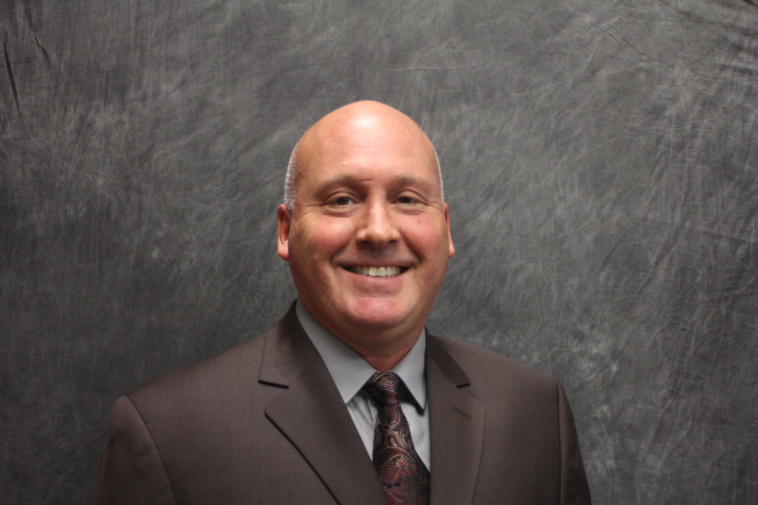

Professor Matthew Jordan

REFERENCES (Contact information available upon request)
Donald Sheehan, Former Foreign Service Officer, US State Department/DOD, Arlington, VA
Dr. Stephanie Ward, Vice Provost for Student Success and Vocation, St. Mary’s University, San Antonio, TX
Dr. Tanuja Singh, President, University of Indianapolis, Indianapolis, IN
Dr. Javier Escudero, Executive Director, Brazil Cultural, Salvador, Bahia, Brazil
Jeremy Grace, Director of MBA Executive Program, AGSM – UNSW Sydney, AUST
Dr. Mark Lokensgard, Chair of Modern Languages, St. Mary’s University, San Antonio, TX
Dr. Diane Friend, Professor of International Agribusiness, Texas A&M, Kingsville, TX
Dr. Jack Elliot, Regional Director for Africa – Norman Borlaug Institute for International Agriculture and Development

